|  |  |
| --- | --- |
| BUSINESS PLAN FOR THE LYMPHATIC RETREAT CENTER | Debra Anne Matthews, LMT, LPN  Lymphormation Center Inc.  675 Main Street  Lewiston, Maine 04240  207-786-6989  [debm@megalink.net](mailto:debm@megalink.net) |

**THE LYMPHATIC RETREAT CENTER**

IS A TWO WAY BRIDGE BETWEEN TRADITIONAL MEDICINE AND

COMPLEMENTARY THERAPIES AND PRODUCTS

**OWNER’S STATEMENT-Debra Anne Matthews**

I have owned and operated the Lymphormation Center, in Lewiston, Maine for fifteen years. I am a State of Maine Licensed Massage Therapist, Licensed Practical Nurse and an Aroma therapist.

My philosophy as a Licensed Practical Nurse and Licensed Massage Therapist has always been to provide compassionate care, unconditional respect for patient/clients’ dignity, physical, mental and emotional needs with high ethical standards. The care I give is established within the client’s boundaries and not my own. My goal is to improve lymphatic health with therapeutic massage, aromatherapy and education/knowledge.

MISSION STATEMENT

The Lymphatic Retreat Center will offer educational opportunities to women seeking to understand and explore their own lymphatic health. Each participant will leave with a better understanding of her body and specific tools to improve her health. We will help women to achieve their goals and enjoy the healthy outcomes in their personal lives at home, work and the doctor’s office. We will always provide compassionate care, unconditional respect for clients’ dignity, physical, mental and emotional needs with high ethical standards.

BUSINESS DESCRIPTION

Lymphormation Center Inc. is a sub-s corporation established in 2003. The Lymphormation Center has three aspects to its success (massage, aromatherapy and education/knowledge). The majority of its current customers are from western, central and southern Maine.

The Lymphatic Retreat Center is a service based business that is an expansion of the Lymphormation Center Inc. It will start operations in the summer of 2016. It will be open year round for 2 day retreats both mid-week and weekends. The goal of the Lymphatic Retreat Center is to share the developed knowledge and curriculum of the Lymphormation Center with more women nationwide. It is for all women who seek to better understand their bodies, as well as, empower themselves to make more knowledgeable decisions, thus, saving time and money.

The Lymphatic Retreat Center differs from the Lymphormation Center in a number of ways. It provides a serene and peaceful atmosphere along a picturesque lake, it provides overnight accommodations for extended relaxation, and it will offer healthy meals featuring many locally grown ingredients. It will be open year round for 2 day retreats both mid-week and weekends. Cost of a 2 day retreat is $325.00, which includes lymphatic evaluation, 2 days of classes, 1 night lodging with meals. Gross sales are projected in the first year (based on 24 retreats with 10 participants) to be $78,000.

PHASE 1:

First year: One employee @ $30.00 per hour 16 hours per retreat. Duties include greeting, registering, organizing, cooking and troubleshooting.

Begin 2 day retreats for women: goal is 24 retreats during first year. Target date for first retreat is June 2016.

Rent an existing waterfront retreat facility in Litchfield Maine. There are 10 private bedrooms, full kitchen and large meeting rooms. Fee is $100.00 per day and includes utilities and heat.

PHASE 2:

Provide Continuing Education (CEU) retreats for massage therapists: projecting 4 retreats per year. Cost with lodging and meals is $400.00 projecting $16,000.

Provide CEU retreats for nurses: establish integrated self-care plans to enhance and maintain healthy lymphatics: projecting 2 retreats per year. Cost with lodging and meals is $400.00 projecting $8,000.

PHASE 3: Purchase land and property with a 25% ($74,750) down payment for Lymphatic Retreat Center. For example; current cost of a turn-key operation (existing Bed & Breakfast) is $299,000. One business report published by CNBC Maine ranked Maine 29th in the country for access to capital in 2014. The following statement was in a press release about recapitalizing a FAME loan program to increase capital in Maine:

Access to venture capital has historically been difficult for Maine entrepreneurs. Maine lags far behind other New England states and the nation in average annual venture capital investment per capita, with only one-third the average annual investment per capita of Vermont and about one-ninth the annual investment in neighboring New Hampshire.

Considering the cost to purchase land and property for this venture and the difficulty in obtaining venture capital in Maine, the financial goal is to rent a facility until sufficient cash reserves are met for a down payment.

The Lymphatic Retreat Center will have a positive impact on Lewiston, Maine and its surrounding communities. It will do this by providing an opportunity for women from other states to visit and explore Maine’s Lakes and Mountains region.

**PRODUCTS AND SERVICES**

The primary service of the Lymphatic Retreat Center is a two day retreat that includes lymphatic evaluation, two days of educational classes and practice, and one night of accommodations with meals. Each retreat will be limited to 10 participants and the price for each participant is $325.

The Lymphatic Retreat Center is a service that improves a woman’s health, therefore, empowering her to be physically, mentally and emotionally stronger to face her stressors on a daily basis. The Retreat Center offers both an educational and experiential learning opportunity for women.

The curriculum includes extensive education on the lymphatic system and the positive and negative impacts that we impose on it daily. Participants will learn about the impacts of stress, sleep, sugar, strenuous activity, and sedentary activity. They will learn about strategies including shallow breathing, posture, ergonomics and diet. The participant will be able to evaluate herself and make appropriate changes or adaptations to improve her lymphatic condition and enjoy the measurable impacts. Women will learn about available tools for use at home and work for improving the lymphatic condition.

At the Lymphatic Retreat Center participants can choose to experience additional services such as a lymphatic massage, a clinical aromatherapy consultation, an aromatherapy steam session, holistic nurse advocacy and bio-impedance analysis. Implementation will be in Phase 2.

**CUSTOMERS**

Our primary target customers are women who have imbalances in digestion, emotions, energy, headaches, allergies, arthritis, joint pain, generalized pain and inflammations. There are many, many more symptoms that arise from a weakened lymphatic system. Additional target customers include women looking to add complementary services and products to their current medical care.

According to Complementary and Alternative Medicine in the United States, Tonya Passarelli, MPHP 439, 4/2008

Demographic Profile of CAM Users (Who Uses CAM and Why?)

CAM is used is widely across all socio-demographic groups and cuts across the U.S. population including groups as diverse as soccer moms, truckers, students, minorities, conservatives and retirees. While there are some trends among CAM users, the absence of a consistently applied CAM definition requires some caution creating CAM profiles. While CAM users are not confined to any one particular group, CAM users, compared to non-users, are more likely to be prevalent among Americans who are: 31

- white

- women

- age 35 to 55

- from western states

- have a higher socioeconomic position

The majority of CAM users tend to be age 35 or older, but usage is reported across all age groups. As reported by Eisenberg, 10% were between 18-24 years, 22% between 25-34, 33% between 35-49 and 35% were 50 years or older. A recent study by Ronald Kessler, Harvard medical school professor, does show a trend towards increasing use among younger respondents. By age 33, 70% of post-baby boomers had used a CAM therapy, compared to 50% of baby boomers and 30% of pre-baby boomers.33

**MARKET SIZE**

One source that helps to explain the potential of the market size is the results of a 2010 survey of U.S. adults 50 years and older conducted by AARP and the National Center for Complementary and Alternative Medicine.

* Women were more likely than men to report using any form of CAM in the past 12 months (51 vs. 43 percent) as well as two particular types: herbal products or dietary supplements (41 vs. 33 percent) and massage therapy, chiropractic manipulation, or other bodywork (27 vs. 16 percent).
* When those who used CAM were asked why they used these approaches, the most common reasons were to prevent illness or for overall wellness (77 percent) or to reduce pain or treat painful conditions (73 percent) (Figure 4). Other popular uses were to treat a specific health condition (59 percent) or to supplement conventional medicine (53 percent)
* Respondents said their health care providers most often discussed:
* Potential of interactions between CAM and other medications or treatments (44 percent)
* Advice on whether to pursue CAM treatments (41 percent)
* Effectiveness of CAM therapies (41 percent), what type of CAM to use (40 percent)
* Safety of CAM therapies (38 percent).

In addition, according to the SBA, (Business Mastery, Fourth Edition, Cherie M. Sohnen), niche health and fitness are hot markets for small businesses.

As reported by National Center for Complementary and Integrative Health

Source: Nahin, RL, Barnes PM, Stussman BJ, and Bloom B. Costs of Complementary and Alternative Medicine (CAM) and Frequency of Visits to CAM Practitioners: United States, 2007. *National health statistics reports; no 18*. Hyattsville, MD: National Center for Health Statistics. 2009.

Credit**:** National Center for Complementary and Alternative Medicine, NIH, DHHS

Massage $4.2 Billion

Self-Care $4.1 Billion

Total: $8.3 Billion

According to Complementary and Alternative Medicine in the United States, Tonya Passarelli, MPHP 439, 4/2008

Higher CAM usage rates for females (49%) compared to males (38%) are not surprising as females tend to be more health conscious and more likely to participate in preventative care. Additionally, women are often the head of healthcare for their families, which may result in increased family CAM usage as well.

According to AARP, NCCIH. *Complementary and Alternative Medicine: What People Aged 50 and Older Discuss With Their Health Care Providers.* Consumer Survey Report; April 13, 2010.

The fact that respondents are the primary initiators of a discussion about CAM or are not talking to their health care providers about CAM because they are not asked or do not know they should discuss it remains largely unchanged from 2006. Thus, the need continues to educate consumers and health care providers about the importance of this dialogue and provide tools and strategies to facilitate this conversation.

The above paragraph supports my belief that there is a definite need in the marketplace for a retreat center that offers both an educational and experiential learning opportunity for women. The success of both massage and self-care therapies is remarkable and growing. The market size within the United States is considerable with the population of aging baby boomers.

In addition a new discovery will certainly focus interest on lymphatics. A recent study by the University of Virginia Health System. "Missing link found between brain, immune system; major disease implications." ScienceDaily. ScienceDaily, 1 June 2015. <www.sciencedaily.com/releases/2015/06/150601122445.htm>.

**MARKET SHARE**

Even the smallest percentage will make this idea profitable, for example, my client base (massage) is approximately 200. Should each one attend only one retreat it would generate $65,000.

Market share will expand with advertising and promotions that will reach out nationwide in the following venues:

* Direct mail to client base, approximately 200
* I have current memberships to both AMTA (American Massage Therapy Association & AHNA (American Holistic Nurses Association)
  + Both memberships provide professional listings, member referrals, online event listings, mailing list rentals and much more.
  + American Massage Therapy Association (AMTA) my member page/website will be set up for retreats at no extra charge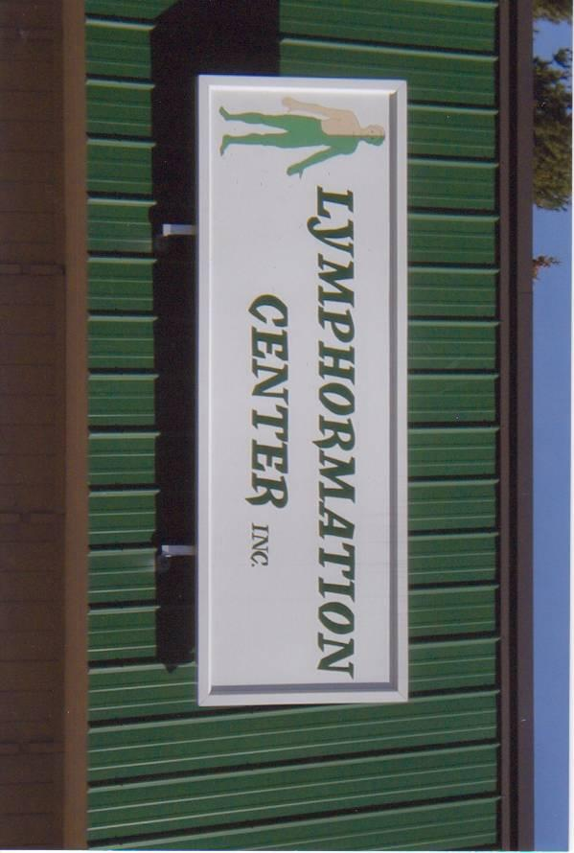
  + Postings on Facebook pages no charge
  + Advertising in newsletters

**IMAGE AND PACKAGING**

All signs, business cards and brochures have contained this logo with my current location and will be used for the retreats as well.

**COMPETITION**

Maine AMTA lists 28 with lymphatic drainage as one of multiple modalities. My current listing, on AMTA specializes solely in Lymphatic Drainage.

Direct competition in Maine and New England is minimal since the Retreat center will be the only facility to offer both massage and a retreat focusing on lymphatic system. In addition, the Lymphatic Retreat Center is unique because I bring fifteen years of experience specializing in lymphatics.

Focus is innovative:

* educational classes are not specific to one modality
* Worth repeating:

Complementary and Alternative services and products encompass many different methods of healing. One is not better than another, however, each woman’s belief system will guide her on a different path from another. This path is both allopathic and complementary. Knowing and understanding which is appropriate at any given time is difficult. The Lymphatic Retreat Center will teach and enable her to understand her “healing” system (the lymphatic system), thereby, navigating her path more knowledgably and efficiently. This will lead to both time and cost management.

* Proven results: The following voluntary questionnaire was provided to clients:

Has your experience at the Lymphormation Center produced any measurable outcome(s) for you and your family? Here are three client responses:

I have been a patient of the Lymphormation Center for over 10 years due to an injury. Over these years I have been able to go back to school and become an RN. I have been able to achieve things that I never thought possible. Both of my daughters are clients of the Lymphormation Center. They have learned valuable lessons on how to keep themselves healthy as caregivers.

Linda

At 21 years of age I had surgery on both knees in which at least 75% of the cartilage in my knees was removed. This led to my very limited to stand the pain with each step. My past 3 years have been greatly helpful by the positive effects of coming for your lymph work. The lymph work helps reduce the swelling and pain in my hips and also in my shoulders. I consider lymph therapy to be vital to my peace of mind, relief of pressure in joints and ability to continue to be mobile.

Polly

I've learned the lymphatics are the body's drainage system and if the lymph system is not working correctly it can cause your body to become inflamed and sick. Now when I get pain anywhere in my body, I know it's important to get my fluids circulating and draining to bring down the inflammation. Keeping my lymphatic system healthy has helped with mental clarity, a stronger immune system, and a way to detox from stress. During my last physical my doctor said my numbers were amazing. I rarely get sick. I believe this was a direct result from years of taking care of my lymphatic system.

Cindy

**PRICING**

2 day retreat is $325.00 includes classes, lodging and meals

**OPERATIONS AND MANAGEMENT**

I am the sole stockholder in Lymphormation Center Inc.

Owner of Advantage Payroll Services franchise for 8 1/2 years.

I have been a licensed massage therapist in Maine for 15 years.

I incorporated my massage business in 2003.

I am also licensed as a practical nurse in Maine.

My business also provided both occupational and physical therapy programs during which time I employed OTR, OTA, PT, PTA, clerical and counter employees.

The retreat center will employ part time clerical for retreat events only, and will employ independent contractors for Holistic Nurse Advocates.

The Lymphormation Center Inc. has posted gross annual sales ranging from $47,000 to $57,000 for a six year period between 2009 thru 2014. 2008 posted gross annual sales of $78,000 which included occupational and physical therapy programs.

APPENDIX

Cash Flow Projection-First 12 months

Balance Sheet

Sources and uses of funds

<http://factbasedhealth.com/rise-complementary-alternative-medicine-healthcare-marketplace/>

<http://www.cwru.edu/med/epidbio/mphp439/complimentary_meds.pdf>

<http://nccih.nih.gov/news/camstats/2010/findings1.htm>

